FOR SALE

2000 Electric Dodge Dakota
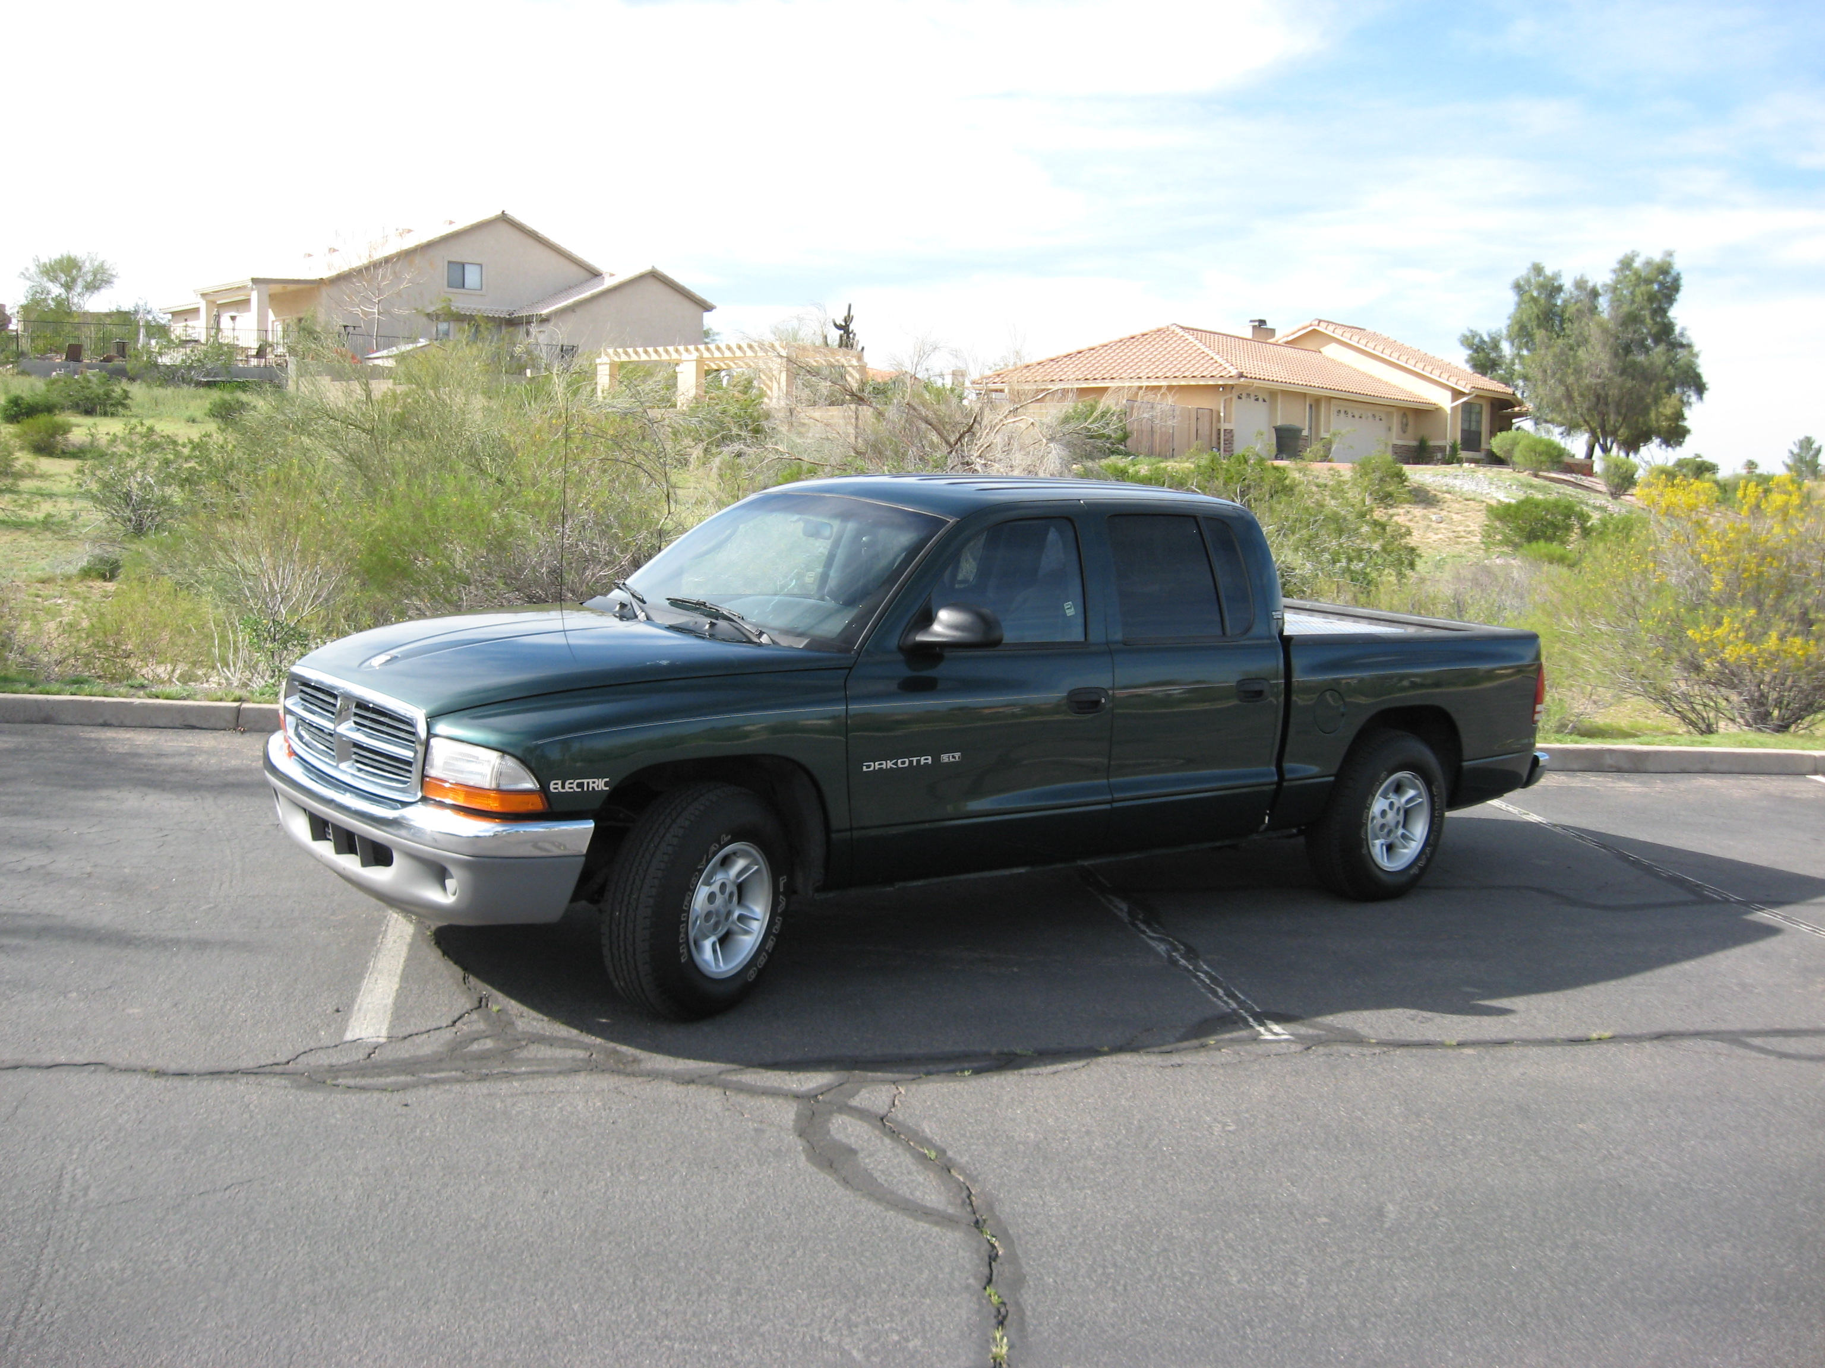

- 2000 Dodge Dakota Quad-Cab, Green, A/C, power steering, anti-lock brakes (rear), power windows, power door locks w/remote
- 9inch Advanced DC motor
- DC Power Raptor controller
- Zivan 120 volt charger
- Zivan DC-DC converter
- Xantrek link 10 Battery Monitor
- 24 Trojan T-145 6 volt batteries
- Optional battery heaters

- 40 mile range

- Event SALES PRICE: $25,000.00

